Creating containers in Proxmox VE (NGINX webserver setup)

Click on your storage > CT templates and then templates

You can search for the OS to filter out the various versions and for this example we will be using Ubuntu Focal. Click on it and click on Download

Once it shows TASK OK you can lose it already



Now you can proceed to create your container. Click on Create CT

Then fill in for hostname, password and confirm password then click on Next

1. "Unprivileged container":

* When checked, the container runs with limited privileges and restricted access to the host system

1. "Nesting":

* Allows the container to create other containers or use certain virtualization features

Select your template and click next

Space can allocate abit more (16GB) and click next

Can leave as 1 core

Memory can set to 1024 and click next

Choose DHCP for both and click on Next

Can leave as is. Click Next and Finish

SSH to your proxmox server and start your container

As seen here it is stopped

Can start by using pct start <container-id>

You can then enter your container shell using pct enter <container-id> and as seen below you should see your CT hostname if you want to know if its successful.

Update the packages

Now we can proceed for our NGINX webserver setup

Important Configuration Files:

* Main configuration: /etc/nginx/nginx.conf
* Site configurations: /etc/nginx/sites-available/ and /etc/nginx/sites-enabled/
* Web content: /var/www/html/

Install NGINX webpackage and dependencies

Ensure nginx is running



Allow the following for firewall

Enable firewall

Create a basic landing page (if you want to use vim may need run apt install vim first)



Test nginx config

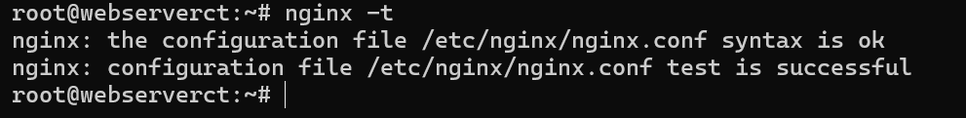

Access your container ip from another PC browser you should be able to see your created landing page now

